# **Manipulator tool and holding and/or expanding tool with at least one manipulator tool**

|  |  |
| --- | --- |
| Patent title | Manipulator tool and holding and/or expanding tool with at least one manipulator tool |
| patent code | US20100263500A1 |
| patent status | Granted |
| countries patent is active in | USA |
| threat to project | 3.5/5 |
| url | <https://patents.google.com/patent/US20100263500A1/en?inventor=Leif+Kniese> |

### **Abstract**

One or more embodiments of a flexible manipulator tools are provided. The flexible manipulator tool can include a distal end movable in at least one manipulation plane with respect to a proximal end. The flexible manipulator tool can also include at least two cheeks extending side by side to and spaced apart from each other.

**Summary**

A compliant gripper/manipulator whose tip can be actuated in at least one axis, with optional wings to increase the surface area of manipulation.

**Claims**

**1**. A flexible manipulator tool comprising:

a. a distal end movable in at least one manipulation plane with respect to a proximal end; and

b. at least two cheeks extending side by side to and spaced apart from each other, wherein the cheeks are flexible at least in the manipulation plane and extend from the proximal end to the distal end, wherein the cheeks are connected between the proximal end and the distal end by at least one at least tension-proof hinge element to permit a shearing movement relative to each other, wherein the cheeks are held at the proximal end at a distance from each other, wherein the one cheek is configured to be at least flexurally stiff and the other cheek to be at least tension-proof, and wherein the at least tension-proof cheek is connected at its distal end to the at least flexurally stiff cheek so as to transmit a pulling force, characterized in that one cheek is embodied to be driven at the proximal end in the longitudinal direction.

**2**. The flexible manipulator tool of claim 1, wherein the cheek that is embodied to be driven at the proximal end in the longitudinal direction is configured to be tension-proof and flexurally stiff.

**3**. The flexible manipulator tool of claim 1, further comprising a tool holder disposed at the distal end.

**4**. The flexible manipulator tool of claim 1, further comprising a tool base connected to the at least one at least tension-proof hinge element.

**5**. The flexible manipulator tool of claim 1, characterized in that at least one flexurally stiff cheek comprises a stiffness changing in the direction from the proximal end to the distal end.

**6**. The flexible manipulator tool of claim 1, wherein one of the at least two cheeks is elongated beyond at least another of the at least two cheeks forming an extension.

**7**. The flexible manipulator tool of claim 1, wherein at least one of the at least two cheeks is supported in an articulated manner at the proximal end.

**8**. The flexible manipulator tool of claim 1, wherein the at least flexurally stiff cheek is embodied as a spring element, and wherein a force form the at least flexurally stiff cheek is introduced into the at least tension-proof cheek in a deformed state.

**9**. The flexible manipulator tool of claim 1, further comprising at least three cheeks, and wherein at least two of the cheeks are driven to move lengthwise.

**10**. The flexible manipulator tool of claim 9, wherein the at least three cheeks are located in one manipulator plane.

**11**. The flexible manipulator tool of claim 9, wherein the at least three cheeks are located in different manipulator planes.

**12**. The flexible manipulator tool of claim 10, wherein adjacent cheeks are each connected by hinge elements.

**13**. The flexible manipulator tool of claim 9, wherein the at least three cheeks are arranged around an interior.

**14**. The flexible manipulator tool of claim 13, wherein the hinge elements are arranged around the interior.

**15**. The flexible manipulator tool of claim 13, wherein the interior is open towards the distal end.

**16**. The flexible manipulator tool of claim 9, wherein the at least three cheeks comprises at least one flexurally stiff cheek and two at least tension-proof cheeks, and wherein the at least flexurally stiff cheek is connected with the at least two at least tension-proof cheeks at the distal end.

**17**. The flexible manipulator tool of claim 1, wherein the at least flexurally stiff cheek is hollow.

**18**. A holding tool comprising at least two jaws opposite one another with respect to a space, wherein at least one jaw is movable with respect to the other jaw, and wherein at least one jaw is formed by a manipulator tool, and wherein the manipulator tool comprises:

a. a distal end movable in at least one manipulation plane with respect to a proximal end; and

b. at least two cheeks extending side by side to and spaced apart from each other, wherein the cheeks are flexible at least in the manipulation plane and extend from the proximal end to the distal end, wherein the cheeks are connected between the proximal end and the distal end by at least one at least tension-proof hinge element to permit a shearing movement relative to each other, wherein the cheeks are held at the proximal end at a distance from each other, wherein the one cheek is configured to be at least flexurally stiff and the other cheek to be at least tension-proof, and wherein the at least tension-proof cheek is connected at its distal end to the at least flexurally stiff cheek so as to transmit a pulling force, characterized in that one cheek is embodied to be driven at the proximal end in the longitudinal direction.

**19**. The holding tool of claim 18, wherein the manipulator tool is hinged at its distal end to the distal end of the other jaw.

**20**. The holding tool of claim 18, wherein the holding tool comprises an integral body in one piece.

**21**. The holding tool of claim 18, wherein the at least tension-proof cheek is adjacent to the space.

**22**. The holding tool of claim 18, wherein the at least flexurally stiff cheek or the at least tension-proof cheek are connected to each other at the prox

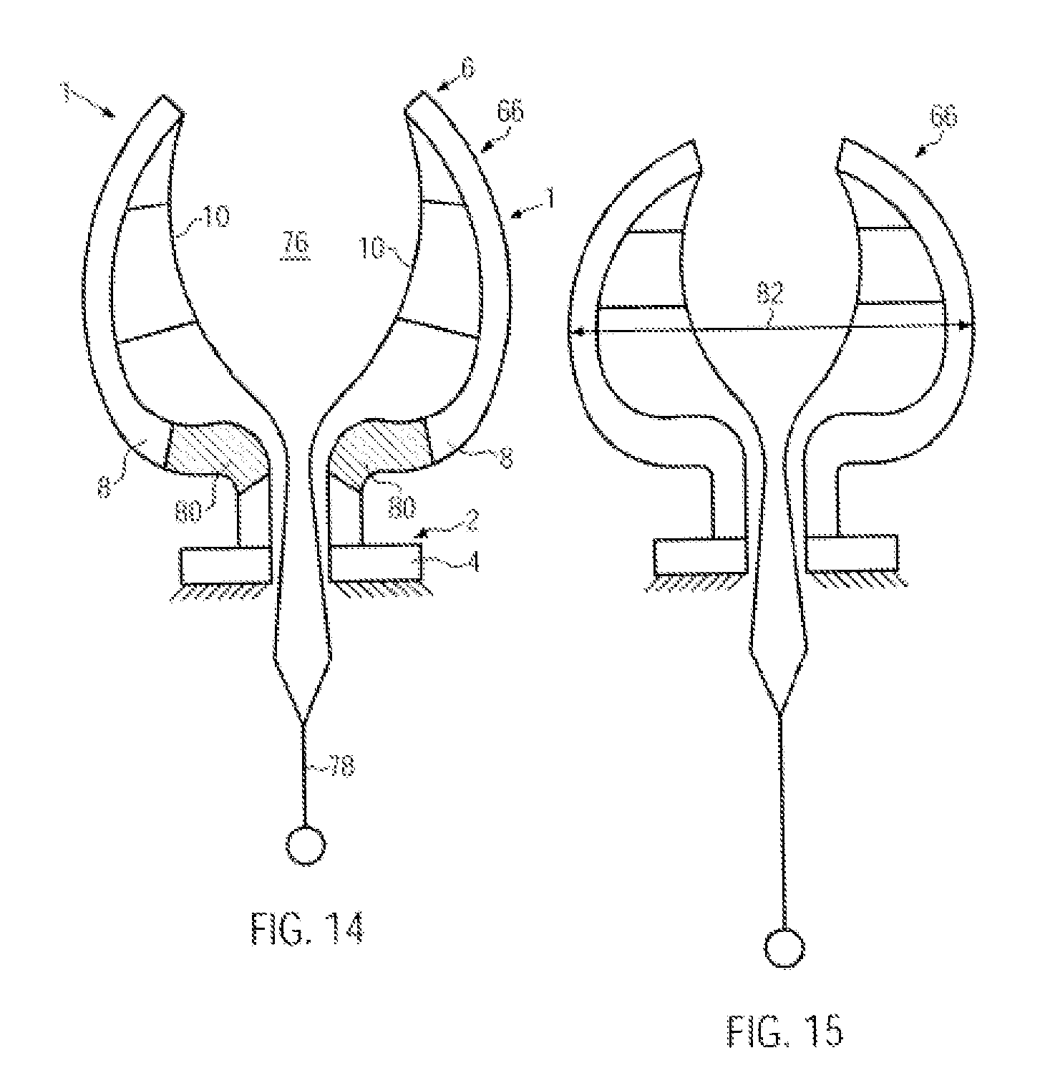

**Interpretation:**

A flexable manipulator tool. The tip has to move in one or more planes. Cheeks (inner and outer surfaces of the gripper) are flexable. Cheeks Extend from base to tip of each ‘finger’. Tension-proof hinge elements are the struts inside the finger. Driven by the inside cheek being pulled down (relative to the image above). Then many potential adaptations of this design (such as tool-holders at the tip, varying stiffness cheeks, different sized cheeks, more than ttwo cheeks, open ended finger-tips, etc…).

**Threats**

Very similar to our proposed fingers (based on the same finray effect (registered trademark). From what we can tell, this device is actuated by pulling the inside cheek down into the palm, whereas our device has each cheek equally flexible cheeks and is symmetrical. Our fingers are actuated by pushing the finger into the object to be gripped. Our fingers cannot flex unless there is an object to be gripped. Also, this patent is only in the US.

**Constraints on project**

We will have to be careful to not have a mechanical means of flexing our fingers without having an object to grasp. If we can actuate our cheek(s) individually then we have infringed on the above patent.